Carl Harrison Heberle b 1934 d 1977 Great Falls MT
Birth: | Jun. 23, 1934
Death: | Oct. 5, 1977
Family links:
Parents:
Goldie H Perkins Berridge (1914 - 1973)
Spouse:
Rita Ann Smith Heberle (1946 - 2012)
Burial:
Mount Olivet Cemetery
Great Falls
Cascade County
Montana, USA
Created by: ZenPanda
Record added: Jun 27, 2011
Find A Grave Memorial# 72100552

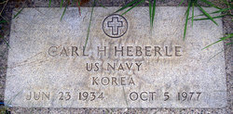
Added by: ZenPanda

